**ARTIFICIAL INTELLIGENCE AND TECHNIQUES LAB**

**CSE2022L**

**School of Engineering and Sciences**

**Department of Computer Science and Engineering**

|  |  |
| --- | --- |
| **Name** | **Hemangi Rudhankar** |
| **Roll No** | **210160223013** |
| **Programme** | **Integrated B.Tech CSE and MBA** |
| **Section/Group** | **A/ T1** |

|  |  |
| --- | --- |
| **Name** | **Devam Shrivastava** |
| **Roll No** | **210160203006** |
| **Programme** | **B.Tech CSE** |
| **Section/Group** | **A/ T1** |

|  |  |
| --- | --- |
| **Name** | **Divya** |
| **Roll No** | **210160203033** |
| **Programme** | **B.Tech (CSE)** |
| **Section/Group** | **A/ T1** |



**G D Goenka University**

Gurgaon, Haryana

**Table of Contents**

|  |  |  |
| --- | --- | --- |
| Sr. No | Content | Page No. |
| 1. | Scope of Project  Description, Stakeholders, Existing Techniques, Scope | 3 |
| 2. | Key Features | 3 |
| 3. | Use Case Diagram | 4 |
| 4. | API Documentation  Python Installation, Packages and Installation | 5 |
| 5. | Code Documentation | 17 |
| 6. | Citations | 23 |

# **Scope of Project**

# A. Detailed Description of Project

* The Attendance System takes input as Lecture name, Session type, Section, and Category from a GUI form and uses the input to open an Excel (CSV) file and a folder of the related input with identity photographs of the student in the lecture of a given input with their Enrolment No. as the name of photograph. The software also has a database of students.
* A camera window opens for face recognition with a timestamp that will be closed after 20 minutes. The face recognized by the system will be compared with the photos and the Enrolment No. of the student extracted from the photo name is stored. When the Excel file is opened it contains Enrolment No. and the Name of the students in that lecture, a new column is added with the current date.
* The stored Enrolment No. is compared with Enrolment No. written in the Excel (CSV) file, when a match is found the student is marked present with a 'P'. The window can be closed by pressing the 'c' button if one wants to close it before 20 minutes. After the window is closed, the students that are unmarked are marked absent with 'A', then the file is saved and closed for later use.

B. Scope of Project

* The Attendance System can be used by faculties and teachers for the ease of marking the attendance of students. It reduces the faculty’s time and effort in marking attendance.
* The files can be updated manually later if needed, introducing new features such as calculating a student attendance percentage or percentage of students present in a class.
* A new subject can be added when needed by the management. New student records can be added for new admission or change of course.
* If needed, an entry time feature can also be added to mark every student's entry timestamp.

C. Details of Stakeholders

* The stakeholders can be the various faculties and administrative members in charge of student attendance.

D. Existing techniques in the area

* Attendance management with a Biometric system and ID card scan system is already implemented in various colleges, schools, and offices.
* Attendance management system using face recognition is less found in practical application.

# **Key Features**

* It uses and maintains a database of student details. With the help of this, the program can be further developed giving the user choice of adding new courses, viewing existing records, etc.
* The program takes the input of one student only once to avoid repetitive marking of students. The first entry will be considered final.
* The program also allows you to customize the time of closing the camera for attendance as per your preference. The default time set for closing is 20 minutes after the camera starts.
* GUI Interface for taking input from the faculty, it makes it easy for the user to give inputs and gives ease of use.

# **Use Case Diagram**

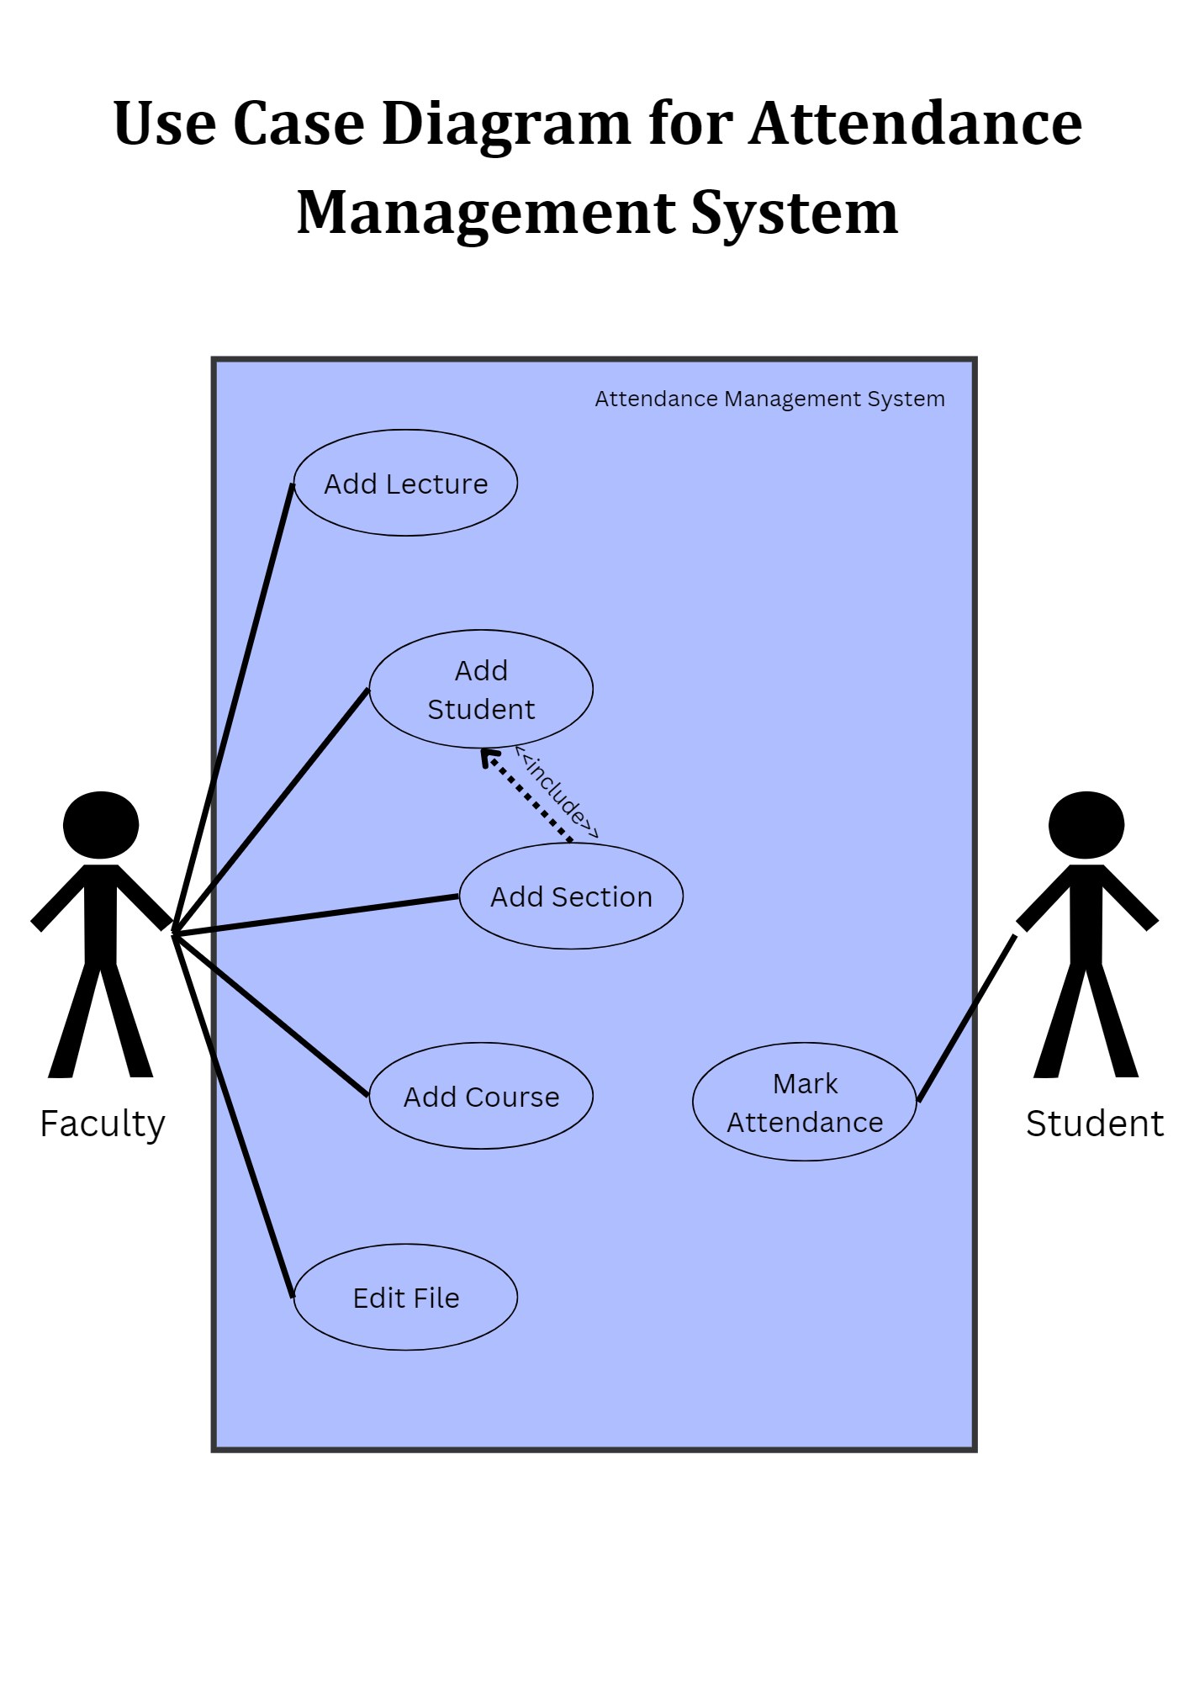

# **API Documentation**

Installations

* Python Installation

Use this link to download Python: <https://www.python.org/downloads/>

1. Open the downloaded .exe file and run the set-up file.

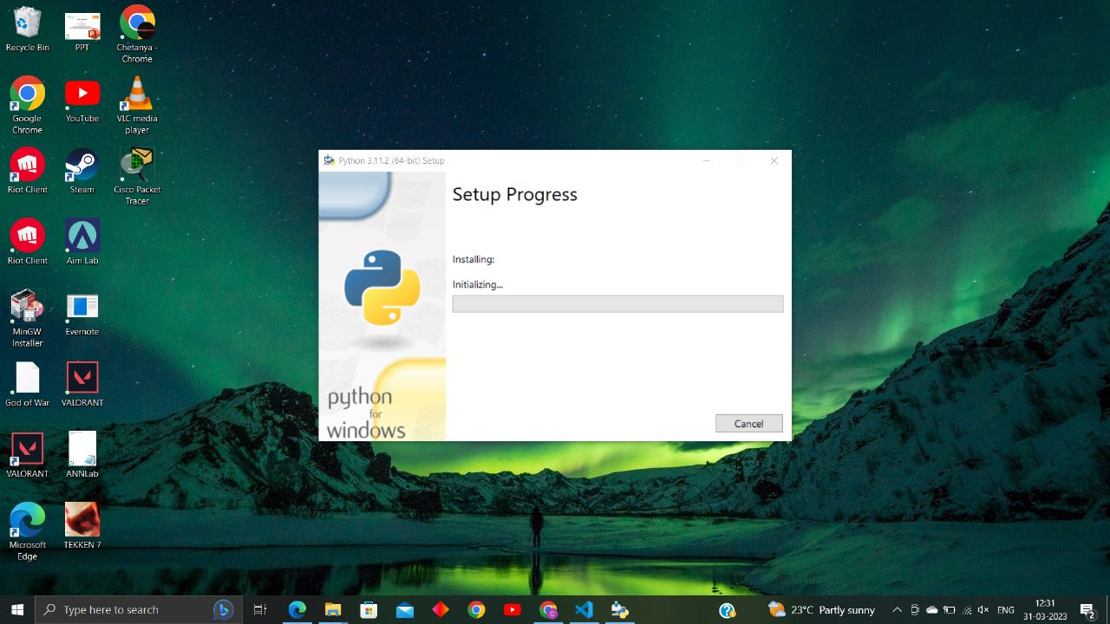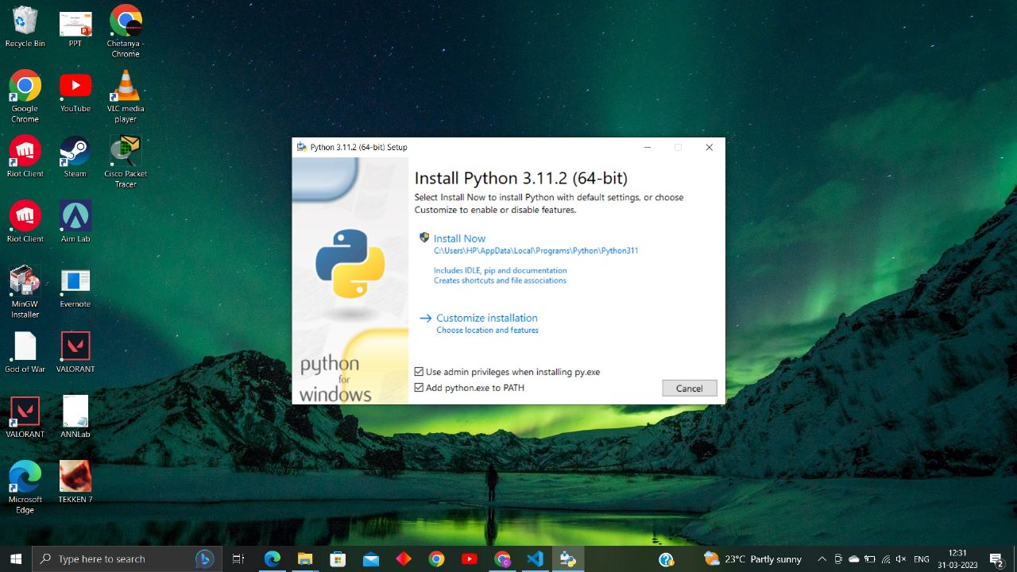2. Check the checkboxes and click on Install Now or click on customize installation for customization.

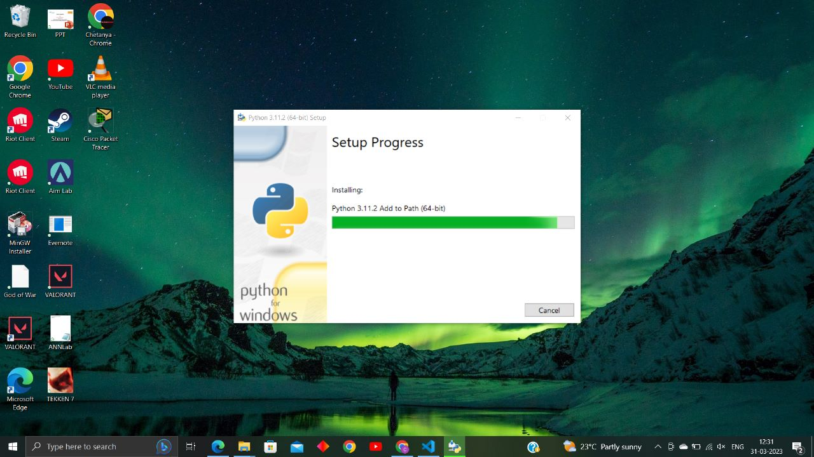3. Let the installation progress bar finish and then click on finish button.

* Visual Studio Code Installation

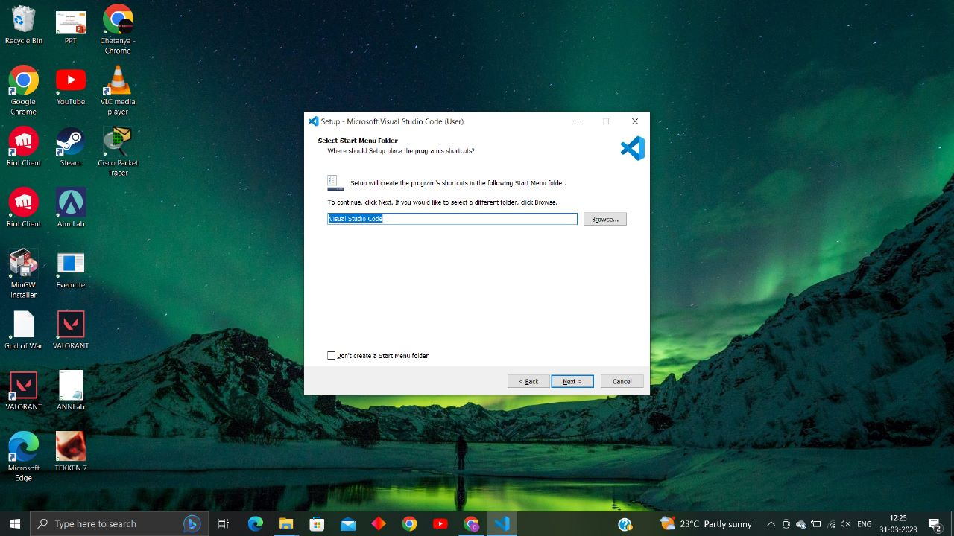1. Choose the folder you want to select and name it. Click on Next.

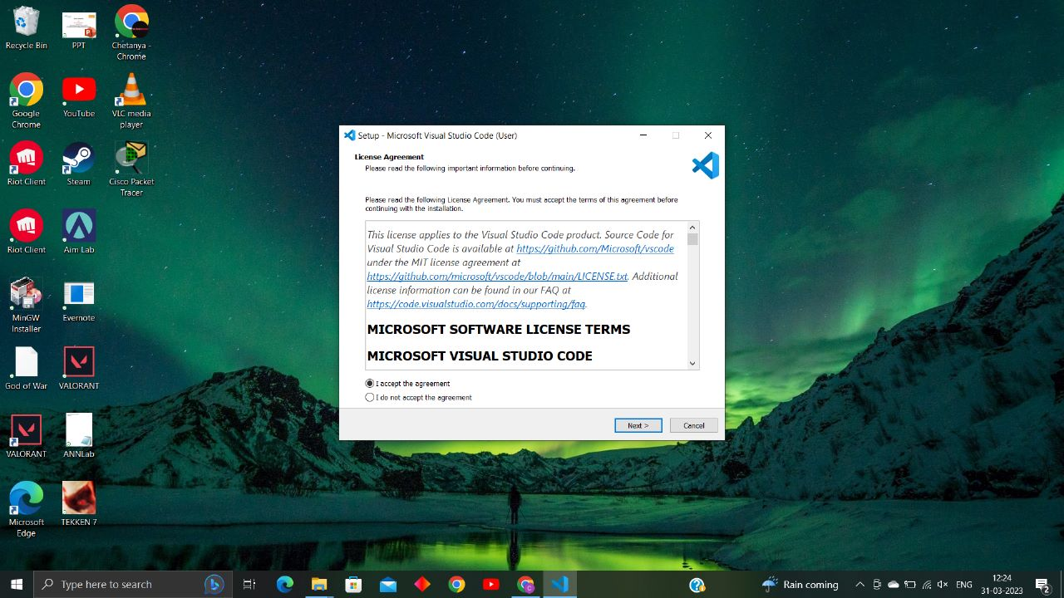2. Accept the License agreement and click on Next.

3. Choose the additional Options according to your preference and click on Next.

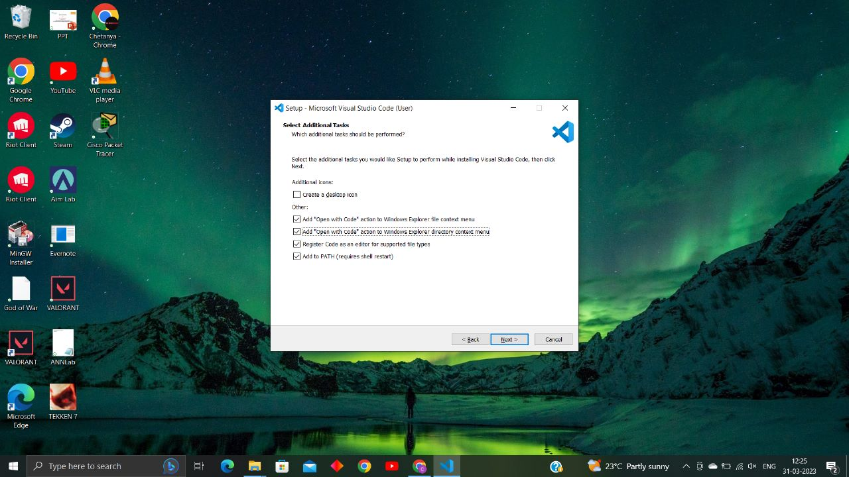

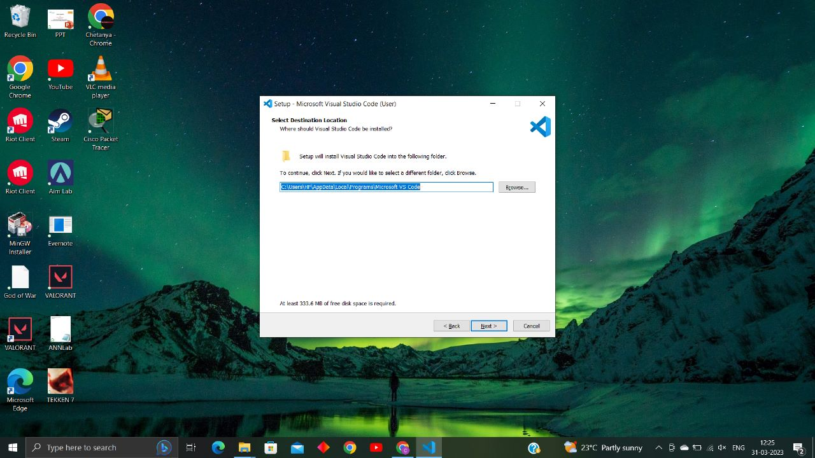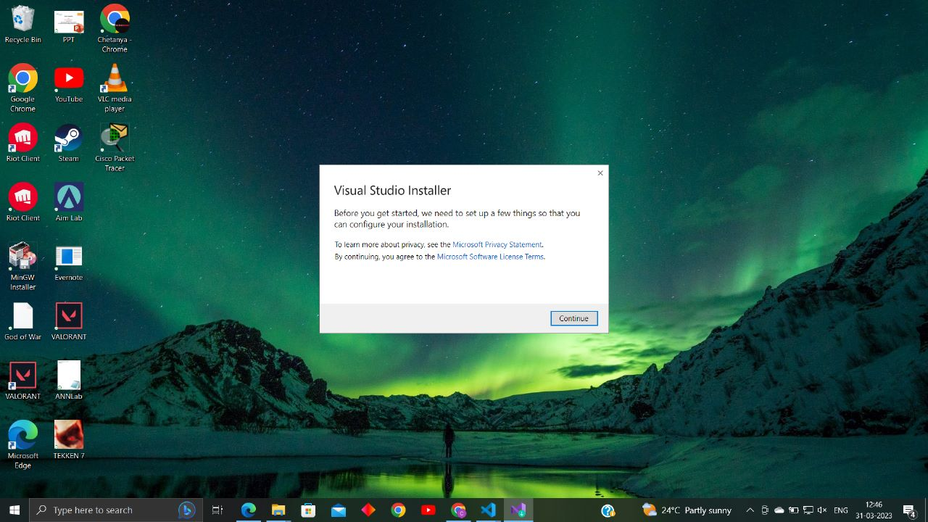4. Click on continue, select the location of the folder for installation and click on Next.

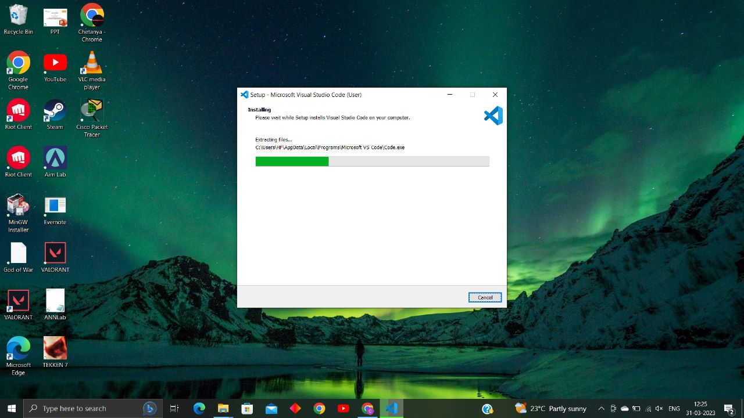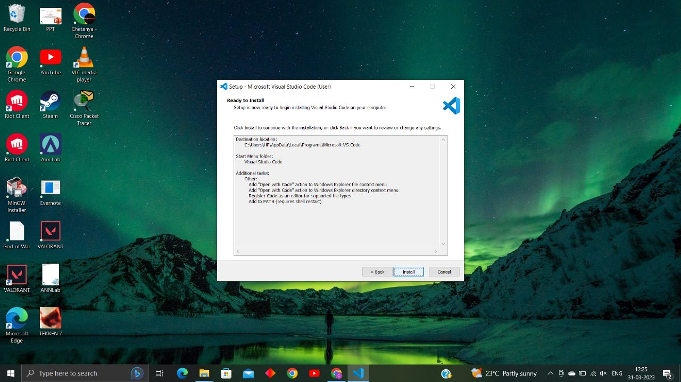5. Check the selected options if they are correct and click on Install.

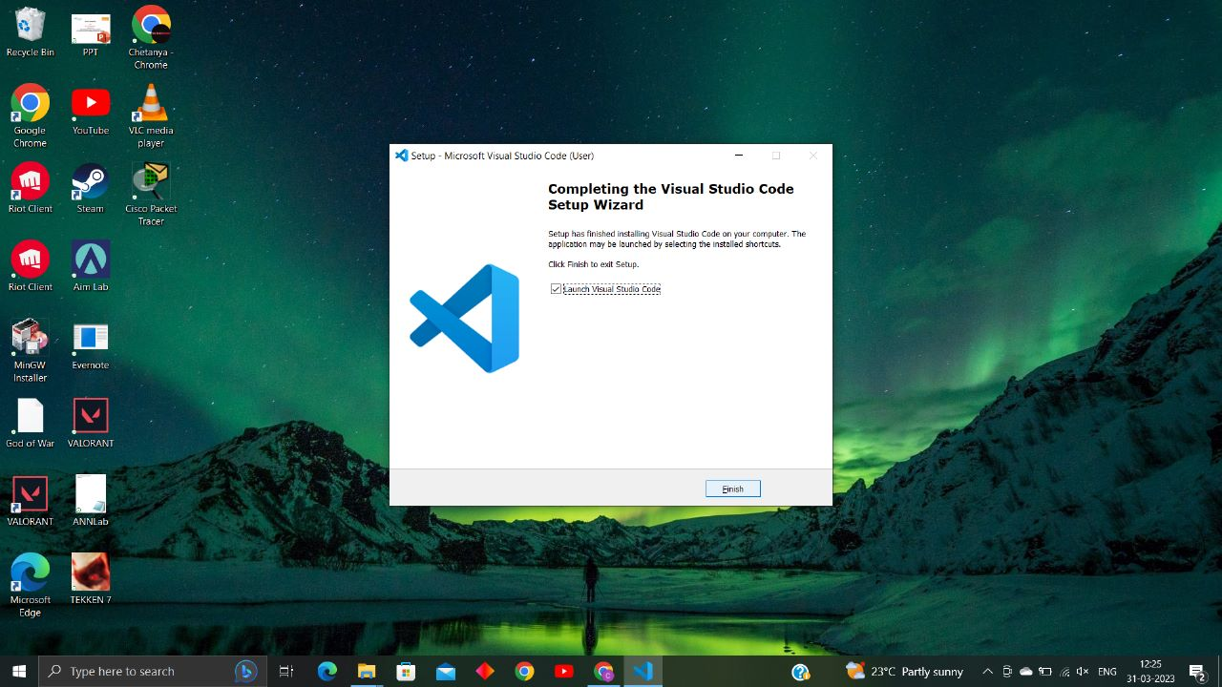6. Click on finish to complete the process.

* Connecting Python and VS Code

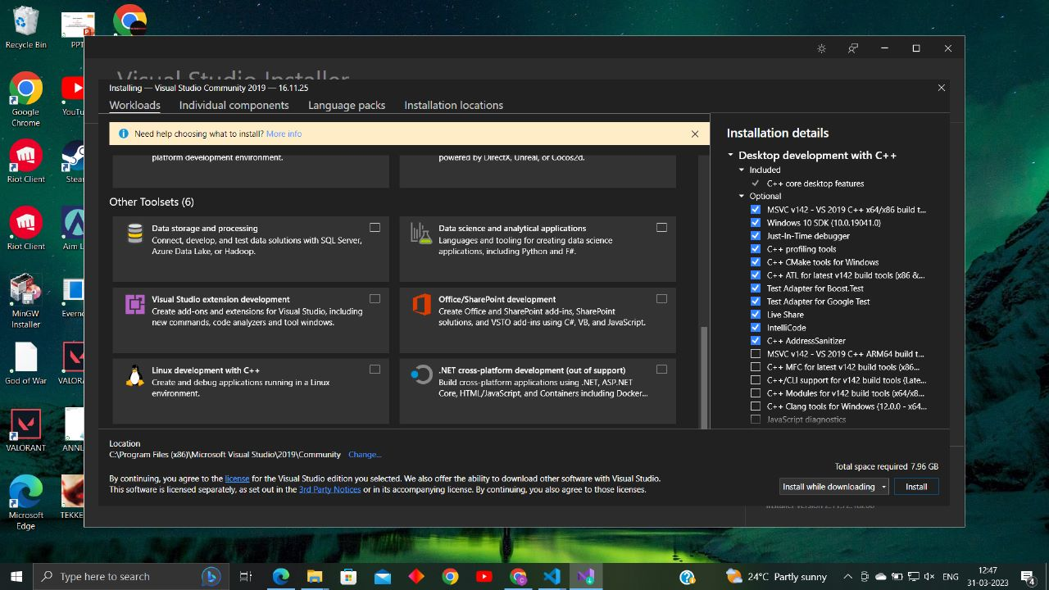1. Choose the languages and tools required or shown in the image below and click on install or install while downloading.

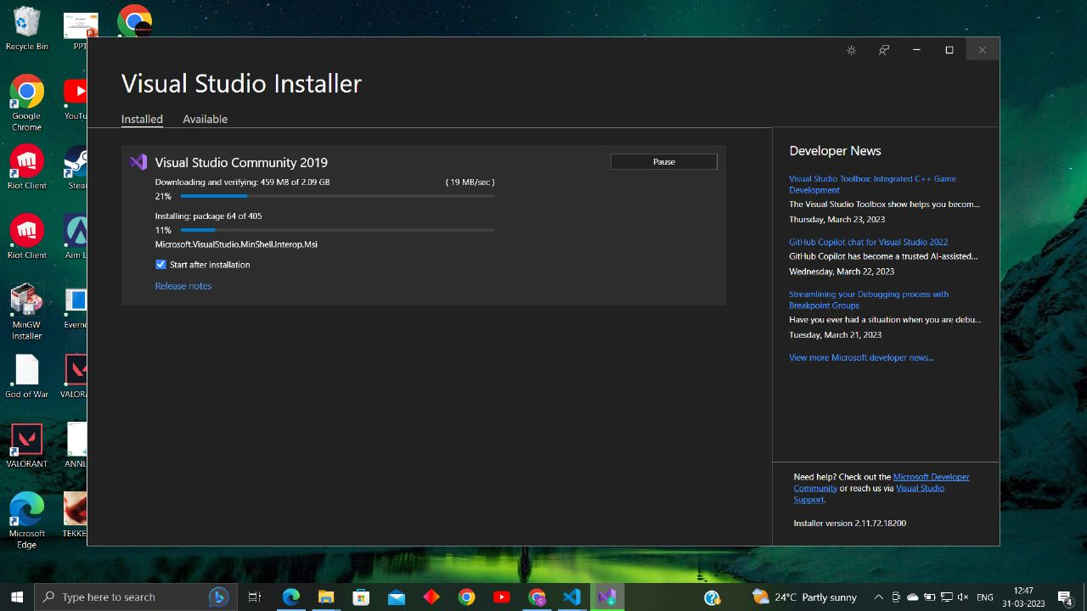2. It should start downloading and installing as shown in the image below.

3. After installation, go to the extension shortcut and search python. Click on the selected extension and install it. Now your VS Code supports Python.

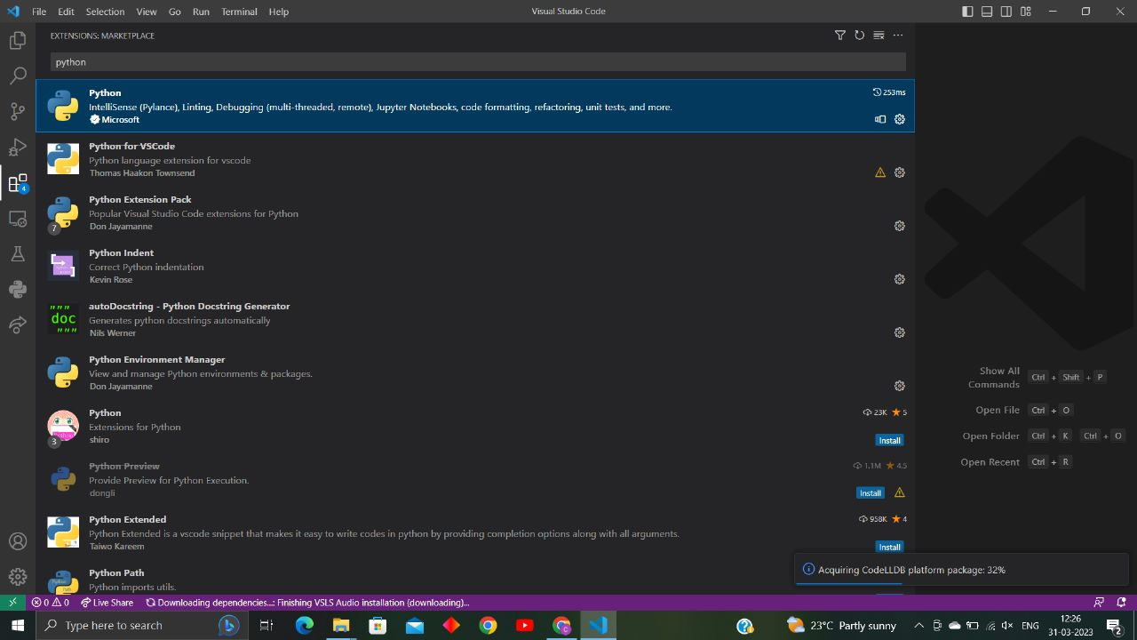

Packages Required and their installations

1. NumPy: It can be used to perform a wide variety of mathematical operations on arrays. It forms the foundation of the Machine Learning stack.

Command: pip install numpy

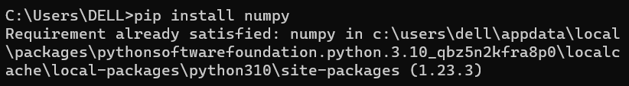

_______________________________________________________________________________________

2. Dlib: It is a landmark’s facial detector with pre-trained models, the dlib is used to estimate the location of 68 coordinates (x, y) that map the facial points on a person’s face.

Command: pip install dlib

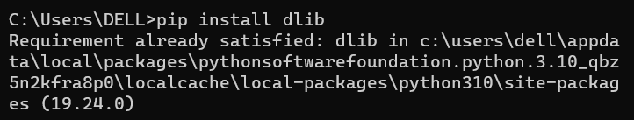

_______________________________________________________________________________________

3. CMake: CMake provides many benefits for single-platform, multi-machine development environments including: The ability to automatically search for programs, libraries, and header files that may be required by the software being built.

Command: pip install cmake

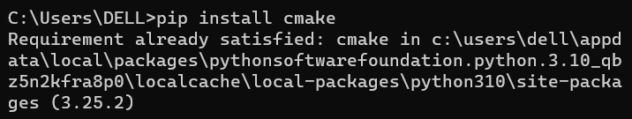

4. Face_Recognition: It lets you recognize faces from a photograph or a folder full of photographs. There’s one line in the output for each face. The data is comma-separated with the filename and the name of the person found.

Command: pip install face_recognition

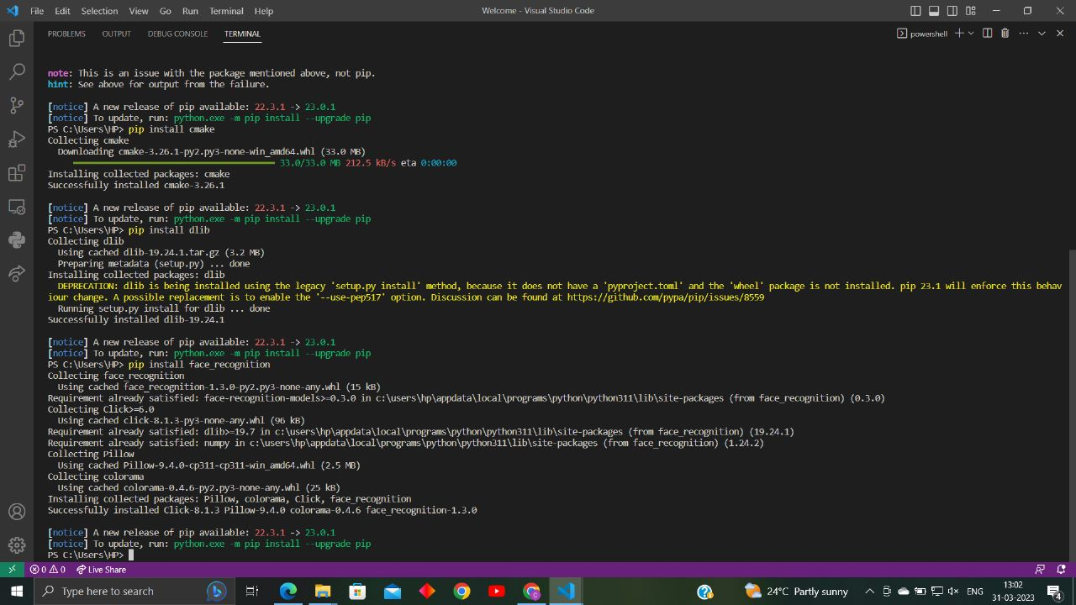

_______________________________________________________________________________________

5. Glob: The glob module, which is short for global, is a function that's used to search for files that match a specific file pattern or name. It can be used to search CSV files and for text in files.

Command: pip install glob2

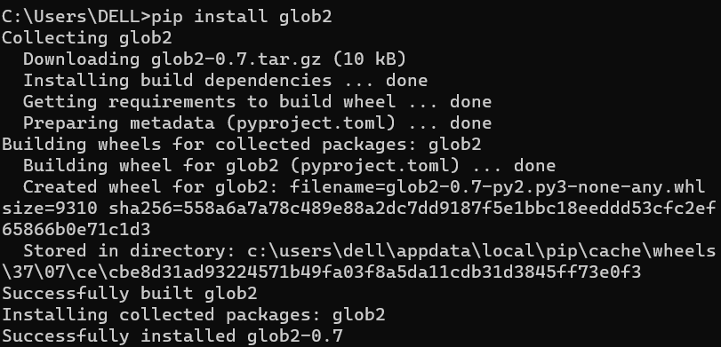

6. MySQL Connector: MySQL Connectors provide connectivity to the MySQL server for client programs. APIs provide low-level access to MySQL resources using either the classic MySQL protocol or X Protocol.[2]

Command: pip install mysql-connector-python

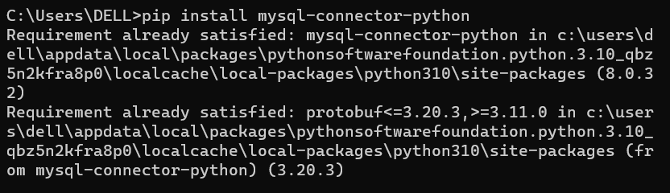

_______________________________________________________________________________________

7. Pandas: It provides fast, flexible, and expressive data structures designed to make working with “relational” or “labeled” data both easy and intuitive. It aims to be the fundamental high-level building block for doing practical, real-world data analysis in Python.

Command: pip install pandas

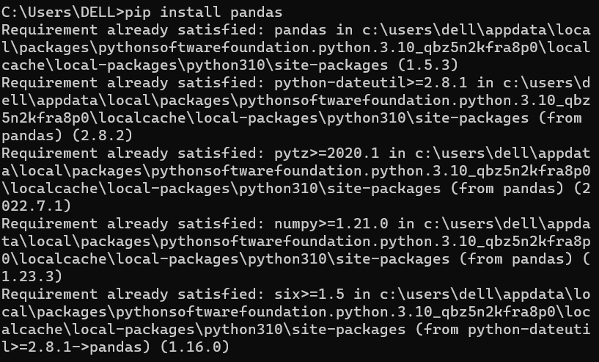

8. Open CV: It is used to provide a common infrastructure for computer vision applications and to accelerate the use of machine perception in commercial products.[1]

Command: pip install opencv-python

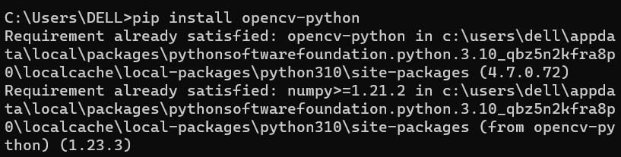

_______________________________________________________________________________________

9. Tkinter: It is used to create Graphical User interfaces (GUIs) and is included in all standard Python Distributions.

Command: pip install tk

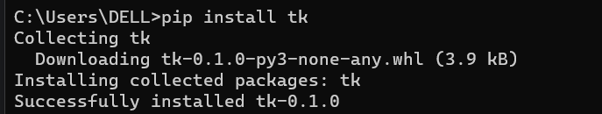

_______________________________________________________________________________________

10. Path: It is used to read and write files. Carefully copy, move, and delete files. Manipulate paths and the underlying file system. Pick out components of a path.

Command: pip install path

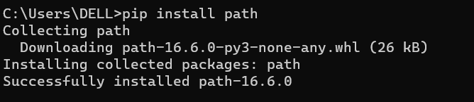

_______________________________________________________________________________________

11. Playsound: It plays a sound specified by the given file name, resource, or system event.

Command: pip install playsound

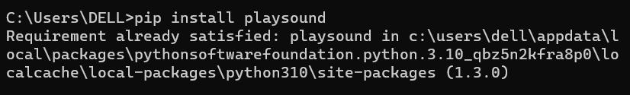

12. CSV: It allows for the data table to be easily retrieved into a variety of applications, they are best viewed within one that will allow one to easily manipulate data that is in columnar format.[3]

Command: pip install python-csv

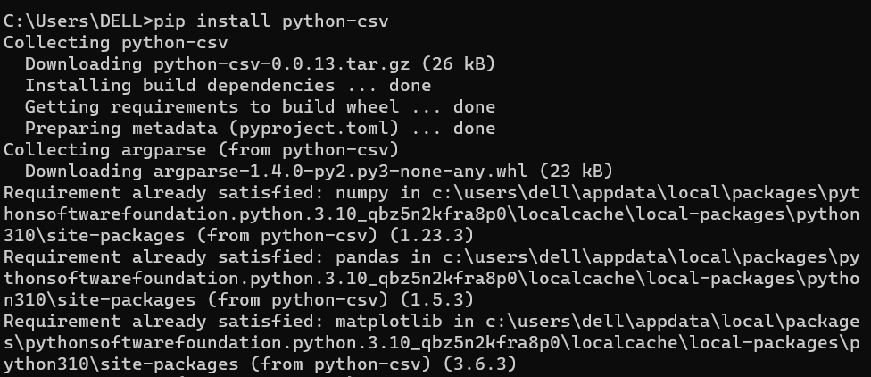

_______________________________________________________________________________________

13. OS: It provides the facility to establish the interaction between the user and the operating system. It offers many useful OS functions that are used to perform OS-based tasks and get related information about operating system.

Command: pip install os-sys

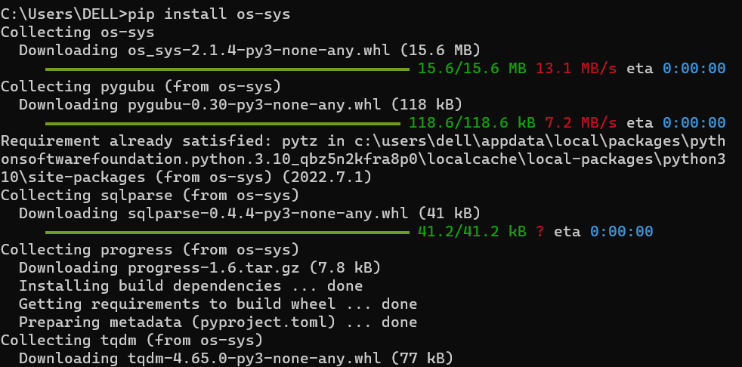

14. Datetime: Python's built-in datetime library is one of the most common modules to manipulate date and time object data.

Command: pip install datetime

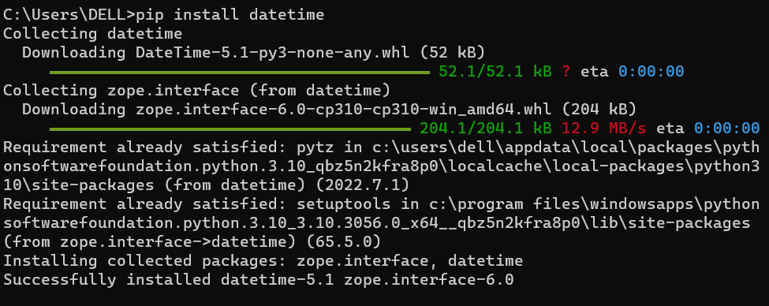

_______________________________________________________________________________________

15. Time: It provides many ways of representing time in code, such as objects, numbers, and strings. It also provides functionality other than representing time, like waiting during code execution and measuring the efficiency of your code.

Command: pip install times

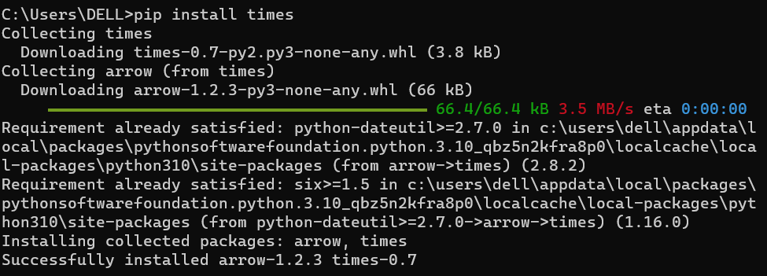

# **Code Documentation**

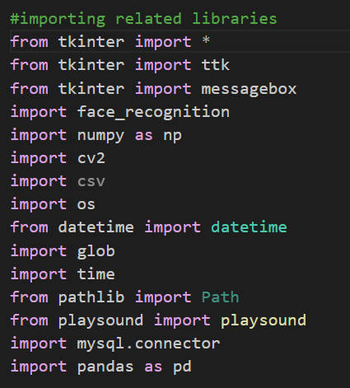Importing all the necessary libraries and modules

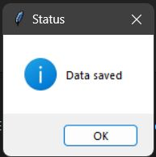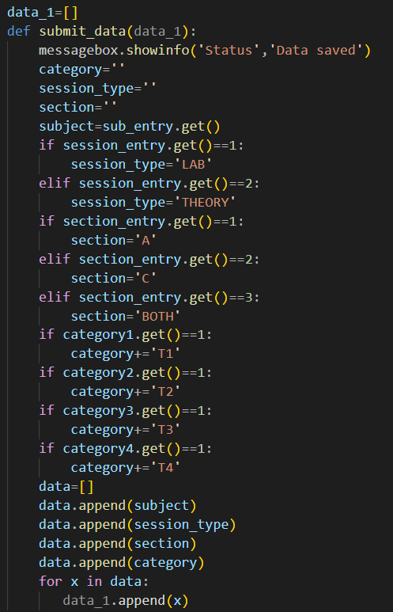This is a function that is called on the press of the submit button of the form and the inputs are stored in a list variable. It also displays a message box showing that data saved successfully. The inputs are stored in an array for further use. The image shows the output when the function is called.

This is the code for the frame window that takes input of the Subject, Session type, Section, and Category. A dropdown menu or combobox is used for the Subject and a list is used to display the subject options in the menu. A radio button is used for the input of session type and section. A radio button helps us to select only one true value from multiple options. A checkbox is used for input of Category. A checkbox enables us to take more than one input from multiple options. Grid( ) function is used to place the labels and input area in the frame window.

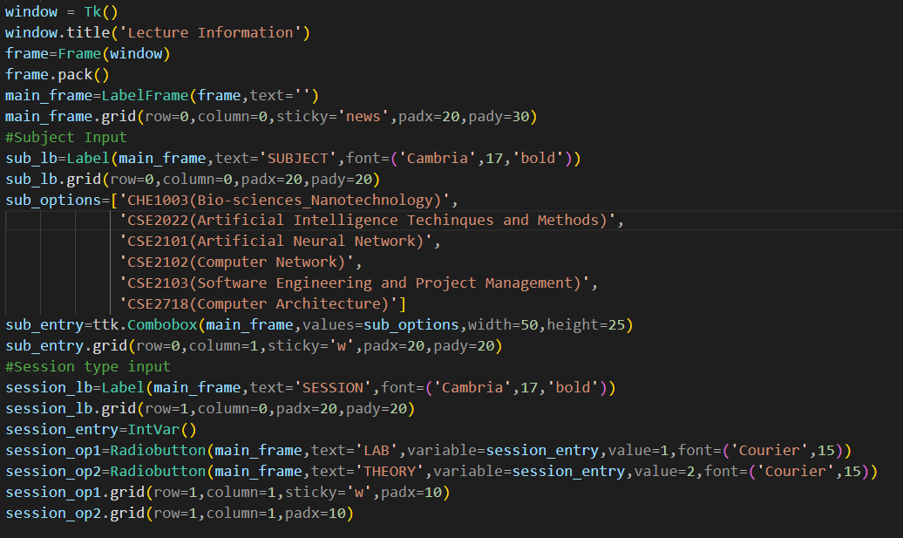

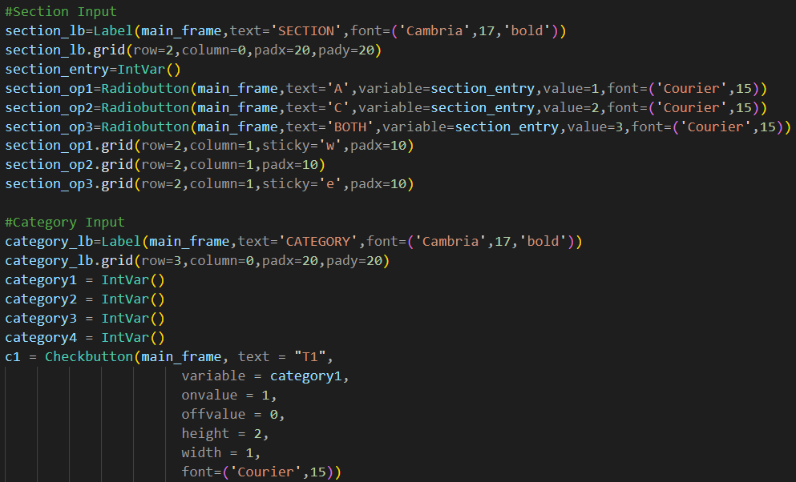

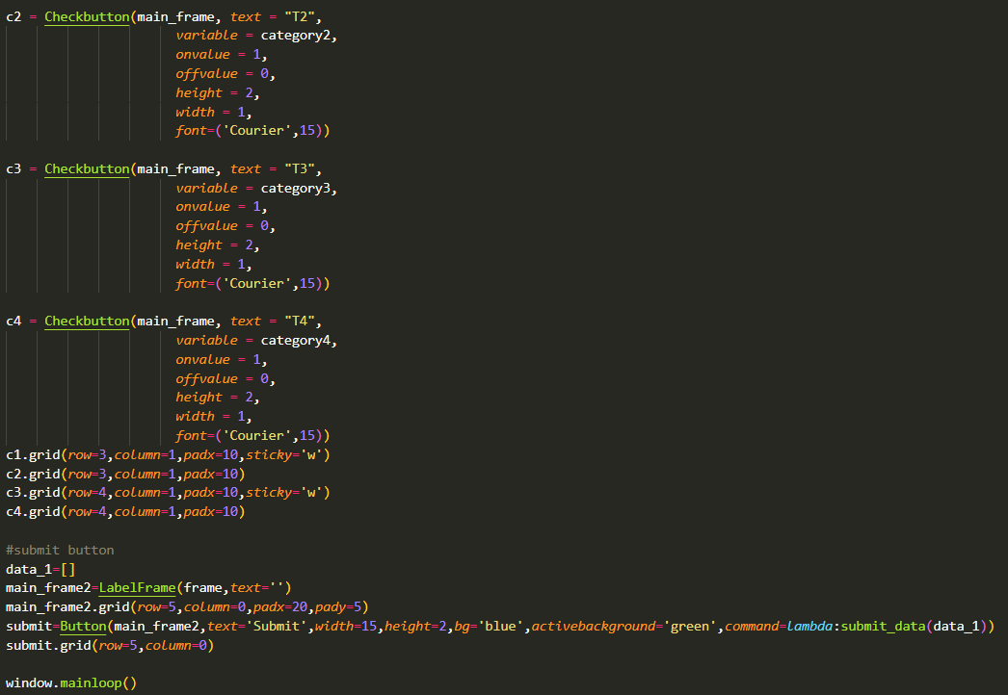

Below is the output of the basic GUI interface when the window frame is called by window.mainloop( ). The interface design can be modified as per the need of the user.

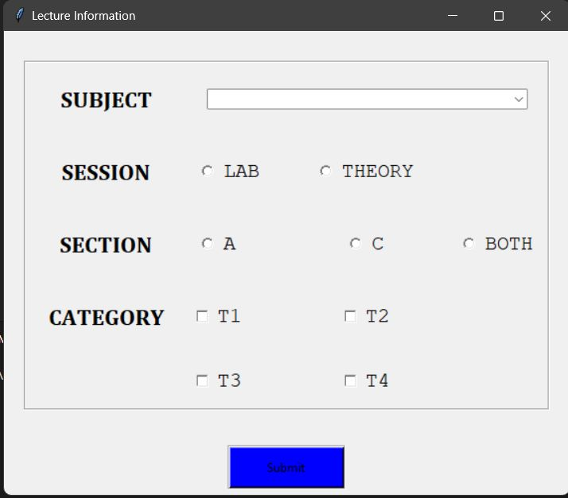

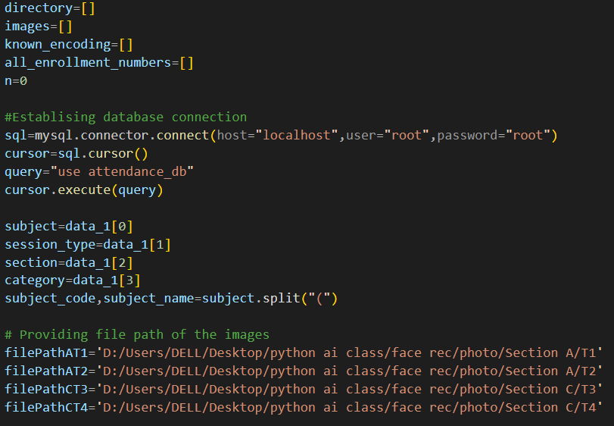Declaring list variables for storing the known enrollments and know face encodings of the images stored in the database file and establishing MySQL connection for updating information from open-cv to database. The database will be used to update the CSV files later. Store the input value from the frame window in the variable and extract the subject code from the Subject input. Creating variables that store the file path of the images stored in file.

Fetching the CSV file based on the given input and adding a column to the existing file by the name of the current date. By default, all students are marked absent. Create list variables to store the encodings of the faces located by the face recognition system. Store the time at which the camera window starts. This variable will be used to close the camera window after 20 minutes to end the attendance session.

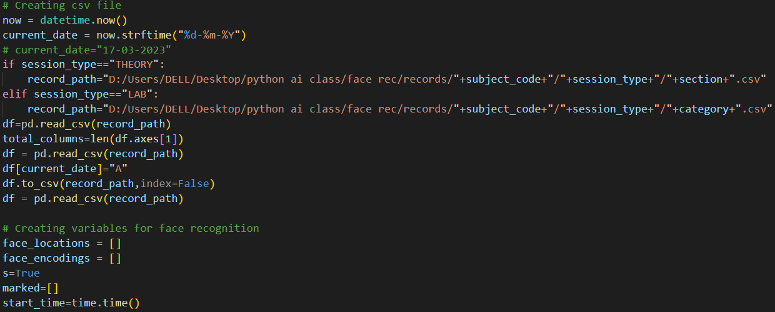

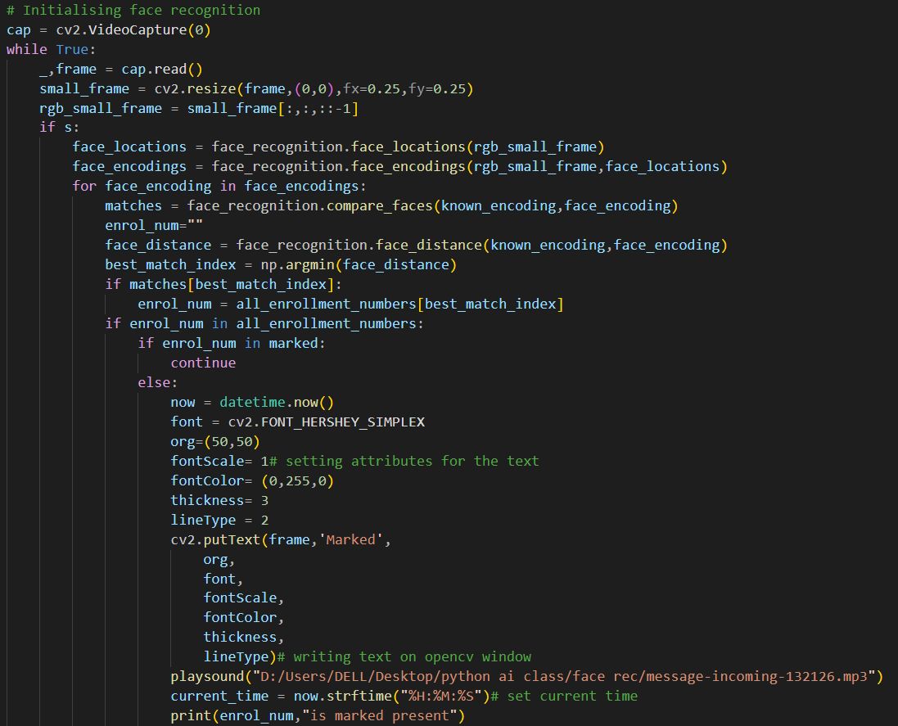The camera window opens for face recognition. The face located are encoded and their best matches are found in the database. The student recognized are marked present in the CSV file and their enrollments are stored in a list so that they don’t get marked again and again for a particular session. When a student is recognized, an output is generated saying that the student is marked and a sound is played. The window closes automatically after 20 minutes. It can also be closed by pressing key ‘c’.

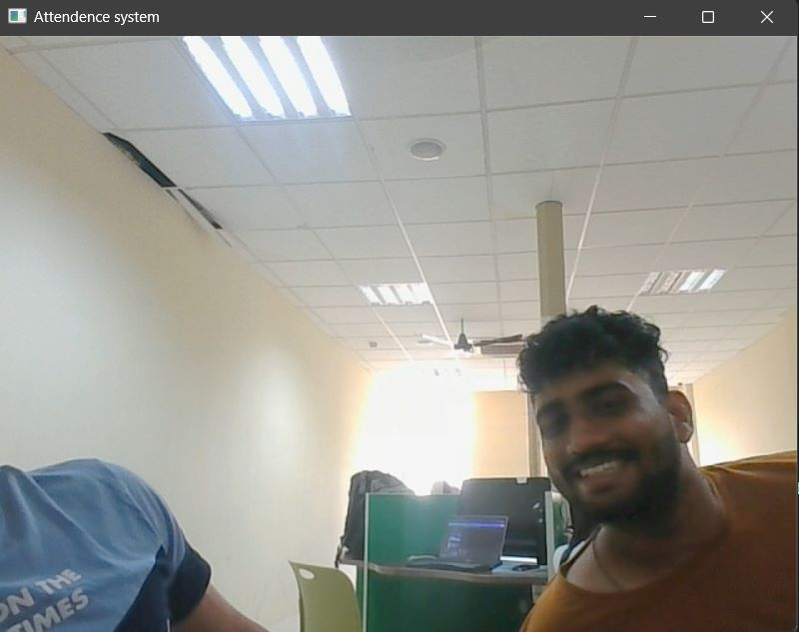The image below shows the face recognition camera window when the video capture function is called. The dimension and properties of window are set by using functions of Open-CV.

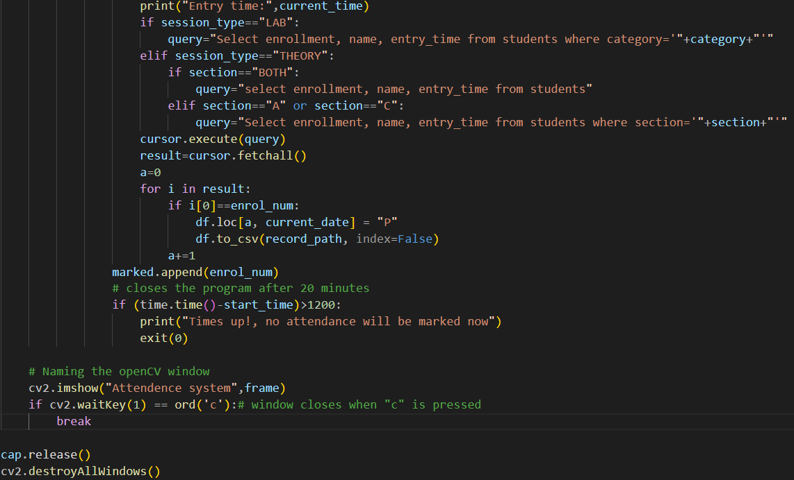The image below shows the CSV file after the attendance is marked. It can be observed that the students with ‘P’ are the one who were detected by the face recognition system.

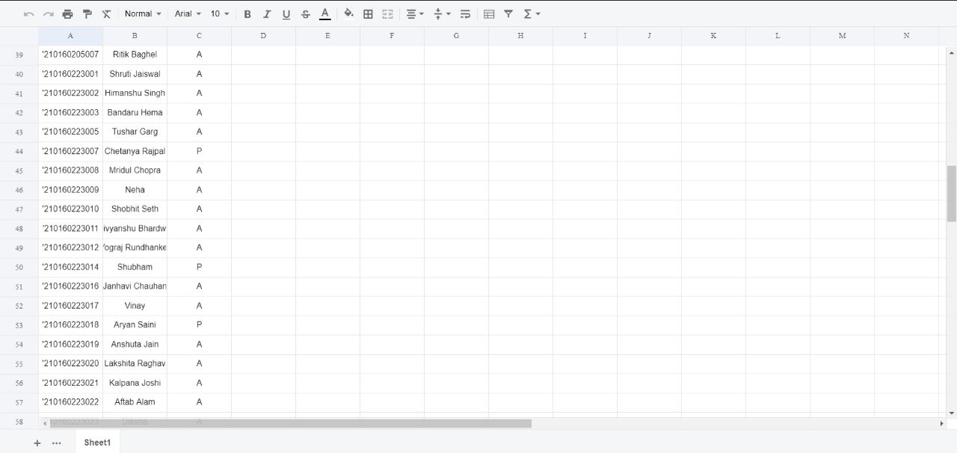

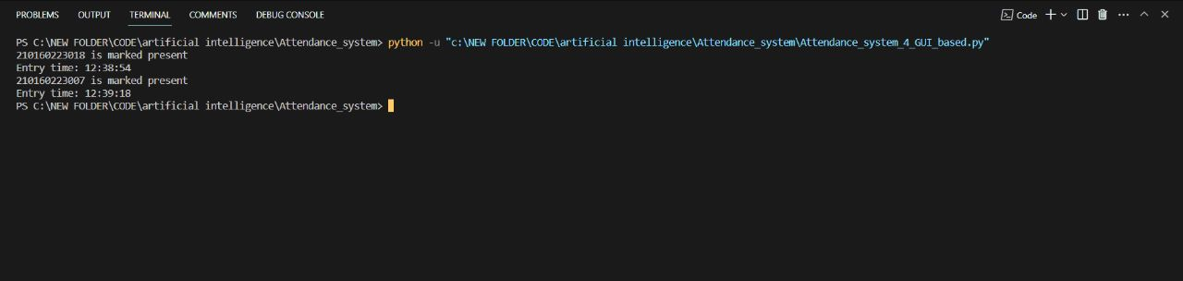This is the console output generated when a student is recognized along with their entry time.cn

# **Citations**

[1] OpenCV - Overview - GeeksforGeeks. (2019, September 23). GeeksforGeeks.

<https://www.geeksforgeeks.org/opencv-overview/>

[2] MySQL :: MySQL Connector/Python Developer Guide. (n.d.). MySQL :: MySQL Connector/Python Developer Guide.

<https://dev.mysql.com/doc/connector-python/en/>

[3] Bonthu, H. (2021, August 21). How to Read and Write With CSV Files in Python? Analytics Vidhya.

<https://www.analyticsvidhya.com/blog/2021/08/python-tutorial-working-with-csv-file-for-data-science/>